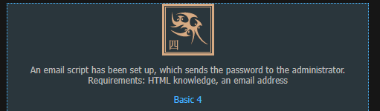

* We know that the requirements for this level are: HTML knowledge and an email address
  + So with that in mind, there could be a possible flaw in the HTML file that allows us to send the password to our personal email instead of Sam’s
  + Let us investigate further via development tools

* We can see that there is a value indicating Sam’s email address, now what if we manipulated the “value” variable to our own personal email address?

* After manipulating the “value” variable to our own personal email address (My actual email has been redacted), we will now be the recipient of the password instead of Sam, let’s see what happens after implementing that password into the text field

* After manipulating the HTML file to become the intended recipient of the password file, we were able to get the password required to complete the room!